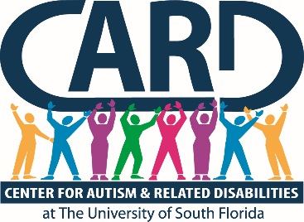

University of South Florida
Center for Autism and Related Disabilities
Final Report and Year End Summary

2017-2018

ANNUAL BOARD REPORT

Submitted By

Karen A. Berkman, Ph.D.
Executive Director

August 15, 2018
University of South Florida (USF)
Center for Autism and Related Disabilities (CARD)
Final Report and Year End Summary
2017-2018

USF CARD Current Registry

 | Registry Data as of  June 30, 2018 | Comparative Data from June 30,2017
Registry Total | 6966 | 6390
Constituents on Registry by County
Charlotte | 102 | 101
Collier | 171 | 164
Desoto | 22 | 21
Glades | 0 | 0
Hardee | 35 | 29
Hendry | 27 | 27
Highlands | 164 | 129
Hillsborough | 3093 | 2822
Lee | 369 | 357
Manatee | 205 | 183
Pasco | 818 | 728
Pinellas | 1069 | 1007
Polk | 637 | 588
Sarasota | 254 | 234
Constituents on Registry by Age
0-2 | 27 | 26
3-4 | 203 | 244
5-15 | 3400 | 3164
16-21 | 1620 | 1476
22+ | 1716 | 1480
Annual New Referrals/Intakes | 606 | 708
Annual Registry Losses | 19 | 50
Annual Web Hits | 4,631,786  (290,708 visitors) | 4,076,135 (218,794 visitors)

*Registry total includes 6896 constituents with autism spectrum disorders (ASDs) and 70 with related disabilities (RDs). ASDs include autistic disorder, Asperger’s disorder, pervasive developmental disorders—not otherwise specified, Rett’s disorder and childhood disintegrative disorder, and RDs include dual sensory impairments or sensory impairments with other disabling conditions.

In accordance with section 1004.55, Florida Statutes (F.S.), and Rule 6A-7.0335, Florida Administrative Code (F.A.C.), USF CARD provided non-residential resource and training services for persons of all ages and levels of intellectual functioning with a documented diagnosis of autism, a pervasive developmental disorder not otherwise specified, an autistic-like disability, a dual sensory impairment or a sensory impairment with other disabling conditions. Services were coordinated with local and state agencies and school districts in an effort to not duplicate services. USF CARD worked closely with its partner agencies across the state of Florida to ensure high quality and equitable local, regional and statewide service provision in accordance with Rule 6A-7.0335, F.A.C., and consistent with the longstanding mission and values of the Florida CARD, a Florida Department of Education (FDOE) program since 1993. USF CARD primarily provided services within its 14-county catchment area, but also collaborated with other CARD centers and state agencies/projects on regional (e.g., regional trainings, Partnership for Effective Programs for Students with Autism [PEPSA] program) and statewide initiatives (e.g., annual CARD conference, development of online training content, support of statewide performance plan indicators, support for the reading initiative). Service delivery was consistent with the other six statewide CARD centers and was coordinated in the collective development of our projects’ annual service plans and via phone conferences with CARD directors and FDOE’s CARD liaison.

Outlined in this report is a summary of activities engaged in by the USF CARD during the period of July 1, 2017, through June 30, 2018. An abbreviated quantitative summary of center constituent registry and service activities is also presented, which reflects our activities across all relevant variables specified in our grant award agreement with FDOE. Detailed programmatic activity and constituent contact data can be found in the project tracking system (PTS) database.

In accordance with Rule 6A-7.0335, F.A.C., USF CARD implemented a plan that included the following:

- A staffing plan with, at minimum, individuals with expertise in autism or autistic-like behaviors and individuals with expertise in sensory impairments.

USF CARD prides itself on having a highly qualified multidisciplinary staff with impressive longevity in terms of years of service to the project. Our project staff members are professionals with expertise in the following discipline areas: psychology, behavior analysis, special education, and social work. Our executive director has been with the project since 2003, and our director has been with the project since 2004. This continuity of leadership has contributed a high level of expertise and administrative stability to our project, which has certainly served to enhance our project performance and outcomes. Our project leader also participates in service grant writing, fundraising, publications and presentations, and is recognized locally and nationally as an expert in the field.

- A direct service plan that must address individual and family assistance in the home, community and school. The project shall not supplant responsibilities of other state and local agencies.

USF CARD provided individual and direct family assistance (IDFA) across contexts (home, school, and community) in fiscal year (FY) 17-18. IDFA is defined by the CARD centers as any contact with any individual and/or family in reference to a specific CARD constituent. Families are advised of the range of services provided by USF CARD and how to access those services when needed. Detailed information on how to access USF CARD services is also available on our website (http://card-usf.fmhi.usf.edu/). All new families who require services complete an intake with a CARD consultant, where the constituent and family needs are assessed and a service plan developed. The CARD consultant with whom the family meets is assigned to the family for ongoing individual and direct family assistance and all related future clinical contacts. IDFA contact data are collected regularly, entered into CARD’s Filemaker reporting database, summarized quarterly and entered into the PTS for quarterly and annual reporting.

Summary of Annual IDFA Data

Total IDFA contacts delivered annually | 6136
Total individuals served annually | 11,933

- A technical assistance (TA) and consultation services plan for providing specific intervention and assistance, utilizing all available community resources, to clients of the project, the clients’ family, school districts, and other service agencies and individuals as appropriate.

USF CARD provided Technical Assistance (TA) services throughout our community in FY 2017-18. TA is defined by the CARD centers as assistance requested by an agency or program that is not related to a specific CARD constituent. Agencies requesting such services are directed to a TA request form on our website (http://card-usf.fmhi.usf.edu/services/request/technical-request.html). Once a completed form is received by our central office, a CARD consultant with expertise relevant to the TA request is assigned to contact the agency, assess need and determine a plan of action. TA contact data are collected regularly, entered into CARD’s Filemaker reporting database, summarized quarterly and entered into the PTS for quarterly and annual reporting.

Within our technical assistance services, CARD-USF partnered with PEPSA to support individual teachers to implement effective educational practices through a teacher partnership program. Teachers, FCIC staff and state-wide CARD staff collaborate to develop classroom innovations. CARD-USF continues to pair a CARD staff member with a selected educator to improve the classroom experience for students with ASD. CARD-USF had four teacher partners during this reporting period. Outcomes are shared statewide through PEPSA’s website and teacher day of the annual statewide CARD conference.

CARD-USF early childhood team and executive director have continued our 5 year partnership with HIPPY to bring their home instruction program to over 16 children with ASD in Hillsborough County during 2017-2018. This year, we presented our data to the international HIPPY leadership as well as at their national conference in San Antonio in April 2018. During that conference, CARD-USF was awarded the prestigious Avima Lombard award for our work bringing the HIPPY model to children diagnosed with ASD. We have had multiple requests to share our work so it can be replicated in other states and countries. CARD-USF completed an operations manual for other states to replicate our model and now offer an online request system to obtain the supplement book for year one children with language delays, the manual and/or technical assistance.

Summary of Annual TA Data

Total TA contacts delivered annually | 4392
Total individuals served annually | 8190

- A professional training program plan that includes developing, providing and evaluating pre-service and in-service training in state-of-the-art practices for personnel who work with the populations served by the project and their families.

USF CARD provided extensive local and regional trainings for professionals in FY 2016-17 in an attempt to ensure that all professionals working with CARD constituents are trained in state-of-the-art “best practices” and are highly qualified. All USF CARD trainings are open to all interested parties in the community, including family members, at no cost. Agencies requesting training are directed to a training request form on our website (http://card-usf.fmhi.usf.edu/services/request/training-request.html). Once a completed form is received by our central office, a CARD consultant with expertise relevant to the training request is assigned to contact the agency, assess need and determine a plan of action. We continue to expand the array of online training content each year. Training data, including participant demographic information, and participant evaluations are collected regularly and entered directly into the PTS for quarterly and annual reporting.

The statewide CARD centers were charged by FDOE to develop an online training module to address the topic of preventing seclusion and restraint of students diagnosed with ASD. CARD-USF is the lead for all CARD Centers on managing the data for the FDOE priority of preventing seclusion and restraint through the online module we created. During this reporting period, 46 teachers, principals, paraprofessionals, behavior specialists, ESE Specialists, social workers and guidance counselors across Florida completed the module successfully.

USF CARD has been working with law enforcement across our region to provide training and technical assistance to ensure positive interactions occur with individuals diagnosed with ASD. We provided several trainings throughout the year to CPI officers as well as police and sheriff’s departments. USF CARD held a Protect and Serve webinar with 47 attendees. We had a total of 4 trainings for 33 CPI trainees and had a training for the Hillsborough County Sheriff’s Office with 9 officers attending. Lastly, USF CARD provided a fire safety training to 110 people, which included Hillsborough County Fire Rescue and Dispatch employees.

Summary of Annual Training Data

Total number of onsite local trainings/workshops | 243
Total number of participants | 5593
Total number of times online trainings viewed | 1988
Total number of visitors for online training page | 5109
Total number of annual regional trainings/workshops and/or summer institutes | 3
Total number of participants | 840

- A public education plan to increase awareness of the public about autism, autistic-like disabilities of communication and behavior, pervasive developmental disorders, dual sensory impairments, and sensory impairments with other disabling conditions.

CARD hosted or participated in numerous public education and awareness events throughout our catchment area in FY 2017-18, including regional community resource and health fairs, autism awareness events with professional sporting franchises (e.g., Tampa Bay BUCS); and many others. Specific events and related data can be found in the PTS.

Summary of Annual Public Education/Awareness Data

Total number of annual general public education presentations | 72
Total number of participants | 9658

- Description of how the project will interface with the medical community to ensure the appropriate use of medical consultation in the provision of services.

USF CARD maintained collaborations with the local medical community, specifically consulting with hospital employees and adaptive care committee to problem solve issues related to patients affected by autism; reviewed training opportunities for hospital staff; consulted with hospitals on using best practices for children diagnosed with autism; disseminated an emergency information packet called Medipal for families to use on a child’s seatbelt or backpack with medical information in an emergency; expanded the medical provider information in the CARD Filemaker database. A resource and referral database of medical providers by discipline has also been maintained. Lastly, we have an ongoing partnership with Special Day Foundation and UF College of Dentistry where CARD provides annual trainings and ongoing technical assistance to new dental residents. We have also created a variety of social experience stories and visual materials for dental offices to ease patient stress and anxiety.

- Description of its working relationship with and support of the constituency board, as defined in s. 1004.55, F.S.

USF CARD continued its close collaborative relationship with its constituency board. The board has maintained its membership of people who represent several USF CARD counties. The constituency board reviewed annual program budget and goals, and hosted quarterly meetings with CARD staff to review programmatic and budgetary priorities. The constituency board operated in accordance with approved by-laws, and proposed constituency board members’ names were submitted to the presidents of USF and the Autism Society of Florida, as specified in statute. Constituency board members participate actively in fundraising events to help support USF CARD operations. Finally, board members participate in relevant trainings related to their own and their family’s needs and interests throughout the year, including the annual CARD conference.

- Dissemination of Appropriate Nutritional Information.

CARD-USF disseminated appropriate nutritional information to constituents in various formats. Information about food chaining and expanding food choices was developed into multiple brochures. In addition, a complete booklet on practical strategies to support feeding aversions was posted on our website and printed for distribution at public awareness events. Trainings on nutrition are archived on the USF CARD website and are available for ongoing viewing by families.

Summary of Supplemental Activities in Support of Program Objectives

The USF CARD executive director has been engaged in working collaboratively with other entities within and outside of USF in supporting the ever-expanding scope of our project and our growing community needs.

As required, USF CARD board and staff have also been quite active on the fundraising front, raising over $69,929 to support our program to offer the community educational opportunities and activities. Included among these efforts are two major events; our annual Fiesta By the Bay fundraising event, and the Rotary Cycling event. The CARD Champion giving society has over 200 members who donated and/or hosted third-party events to benefit USF CARD. USF CARD also takes the leadership role with the CARD Autism Champion student organization at USF.

USF CARD continues to strengthen its program through the cultivation of strategic community partnerships. This past year, we continued building on the close relationships with our 14 school districts, continued our collaboration with the medical and diagnostician community through trainings and resource dissemination, and enhanced our community outreach efforts through numerous public awareness efforts, in collaboration with local schools/agencies.

Our team continues to offer regularly distributed substantive and informative newsletters. The CARD Connector is a brief monthly newsletter that clinicians from around our communities may contribute to as well as our constituency board chair along with announcements. The CARD Community Connection newsletter is a full edition that comes out two times a year. They are both on our website archives.

USF CARD has successfully completed another year of its “autism friendly business initiative” having worked with over 50 large and small companies in and around the Tampa Bay region. During this fiscal year, USF CARD partnered with the City of Tampa to become “autism friendly.” We provided training for the City of Tampa Police department and first responders. In addition, training and materials have been delivered to 12 parks and recreation facilities within the city. In total, over 2500 city employees were trained. Lastly, we posted an online social experience story for the downtown Riverwalk area of the city for families to download. USF CARD staff was appointed to the Mayor’s Advisory Committee in the 2017-2018 fiscal year to continue expanding and monitoring this project.

CARD-USF participated in site visits with FDOE to four school districts cited for above average numbers of seclusion and restraint in their schools. We were an integral part of assisting the district develop a plan for managing this issue.

CARD-USF facilitated three ESE District Workgroup meetings. The agendas included CARD-USF information, updates from the districts, and an opportunity to discuss varying topics regarding building continued success for their schools.

CARD-USF supports USF students by providing leadership and mentorship. We hosted an MS student from the school of behavioral studies and one from the Rehabilitation and Mental Health Counseling Programs. The executive director sat on two doctoral student’s committees from the School Psychology program and School of Education program. CARD staff serves as the Advisor for the CARD Autism Champions student organization at USF. We also collaborated with the USF Health Service Corps for community events. In our ongoing relationship with the School of Pharmacy, we have provided presentation to their students. We also have work study students within our program who learn about ASD and serving families

Special Events and Projects:
- Hosted the 25th Annual Statewide CARD Conference
- Collaborated with ZooTampa, The Florida Aquarium and MOSI for the sensory friendly event “Day of Discovery” during autism awareness month-hosted Promising Pathways conference in Ft. Myers
- Hosted Fiesta By the Bay Fundraiser
- Safety kit campaign for autism awareness
- co-hosted the summer institute for teachers
- Collaborated with the Florida Orchestra for their sensory friendly event
- Collaborated with the Museum of Fine Arts for their Star Wars™ costume sensory friendly event
- Advisor to USF Student Organization: CARD Autism Champions
- Updated resources for CARD library
- Trick or Treat with the Greeks at USF
- Board Game Night for young adults
- Night of Giving reception

2017-2018 CARD Annual Caregiver Satisfaction Survey

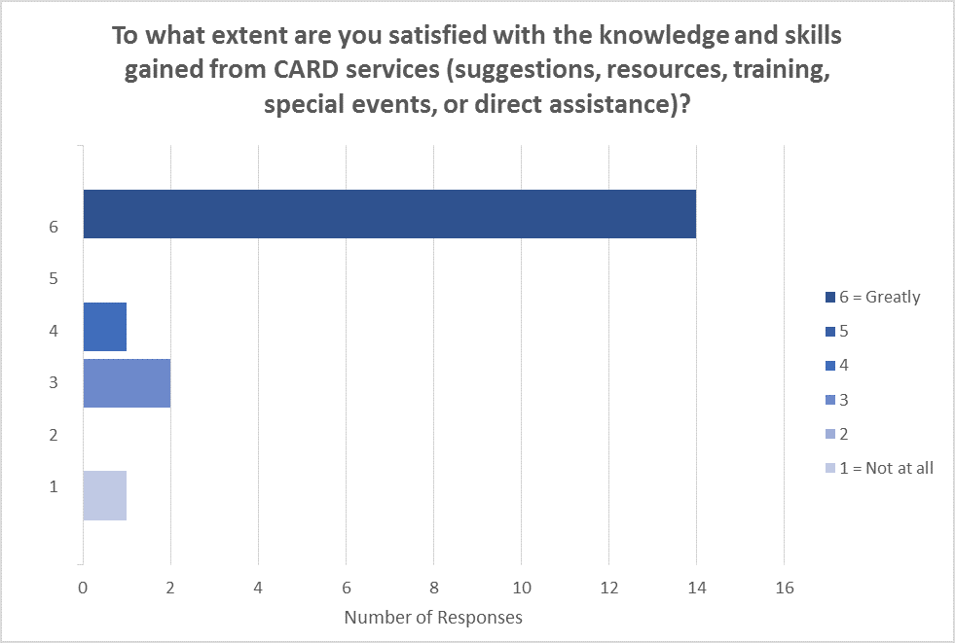
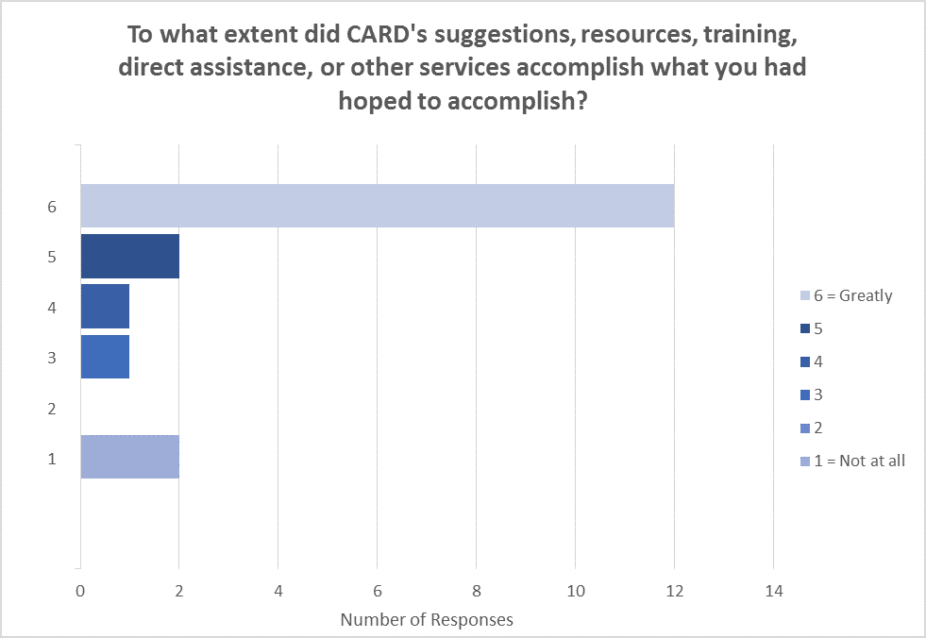
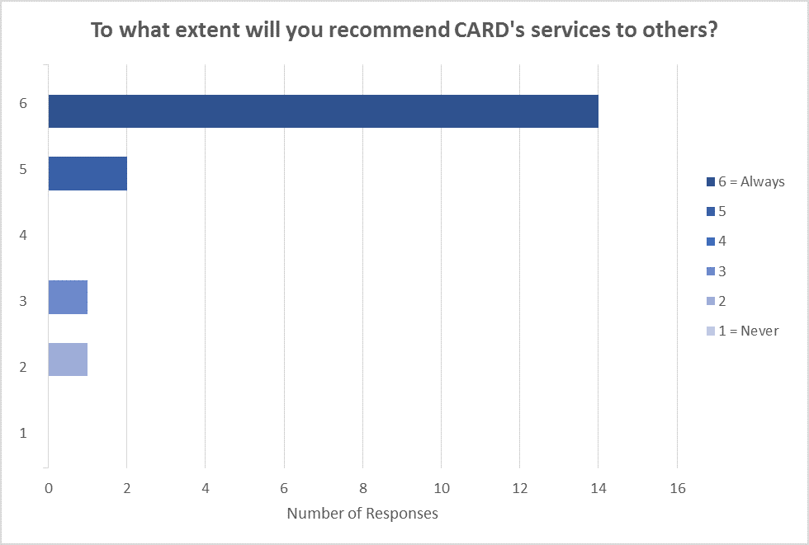
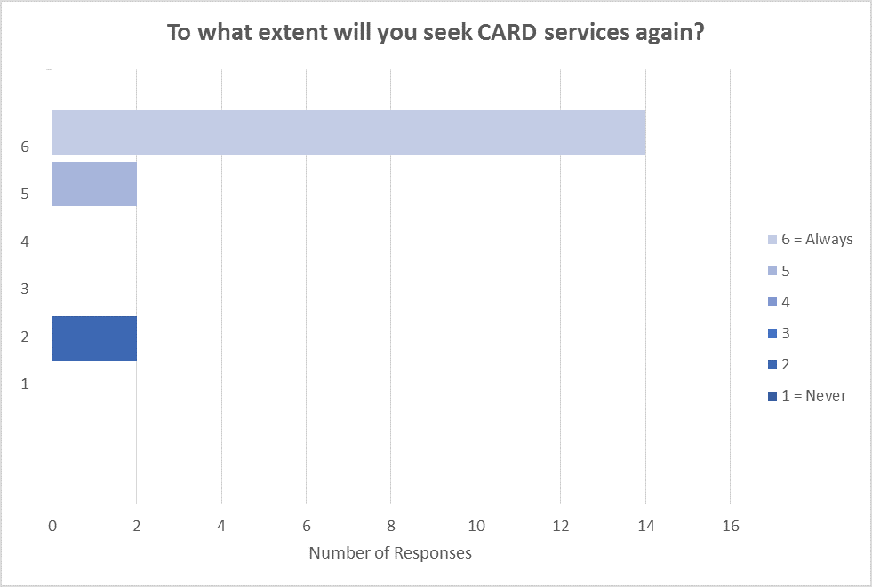

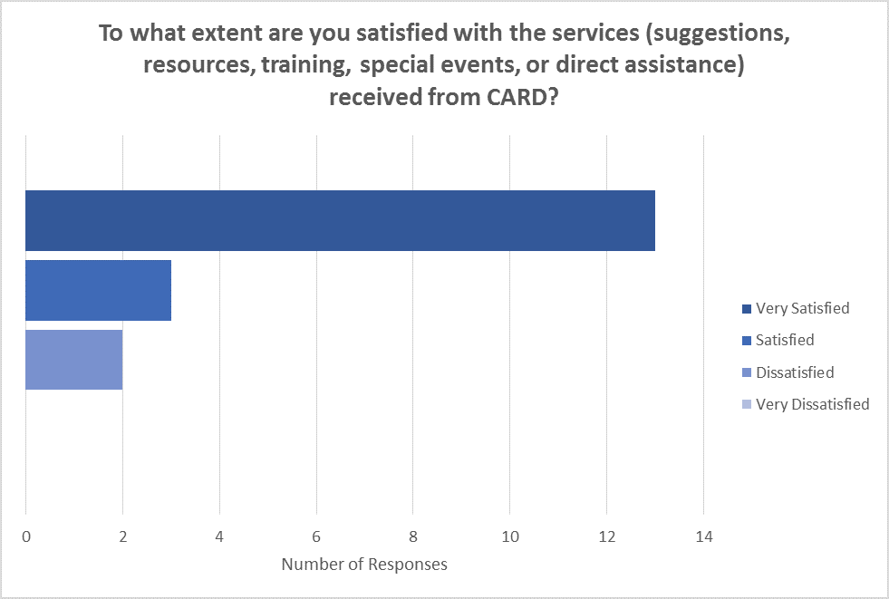
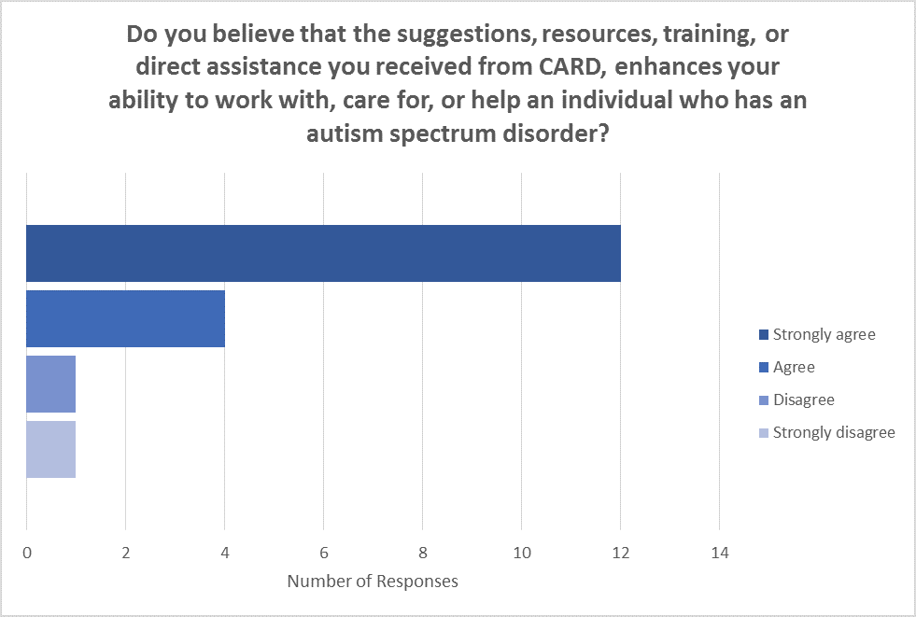
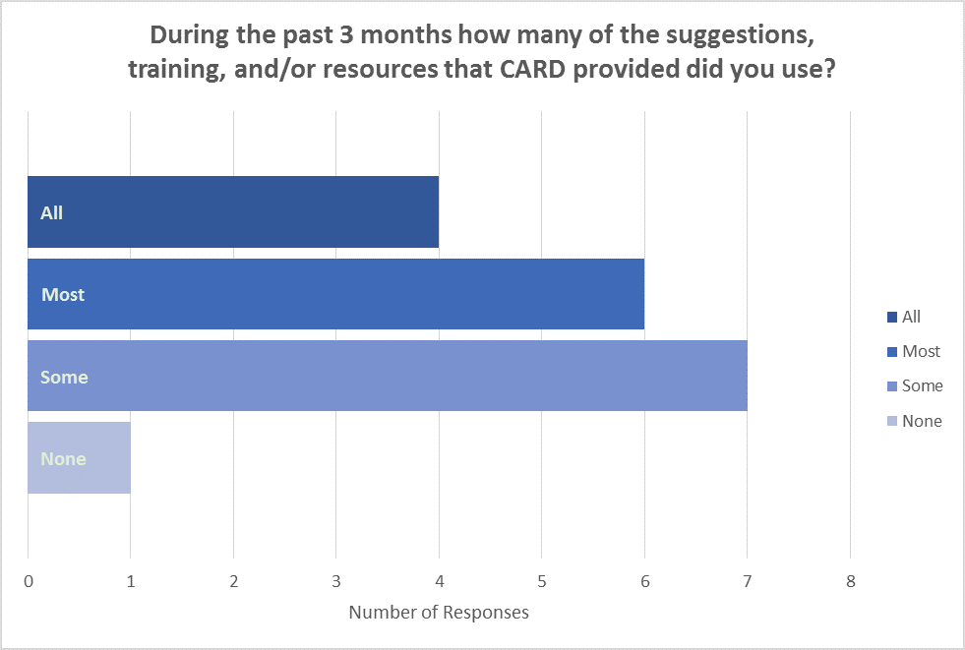
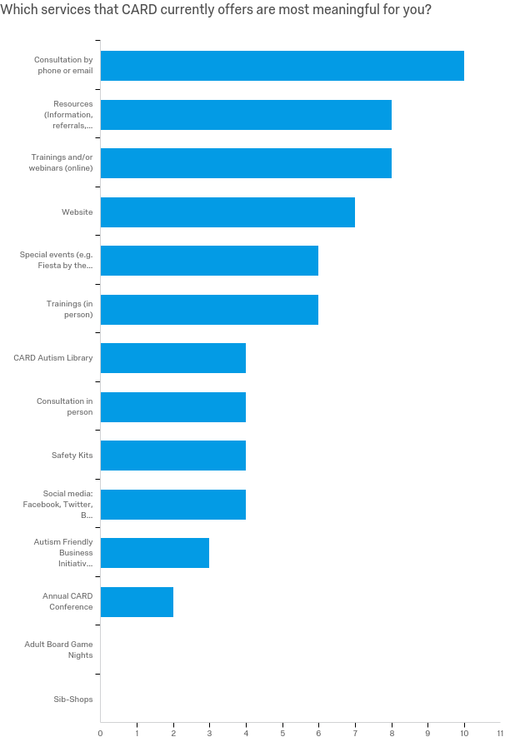
2017-2018 CARD Satisfaction Survey for Technical Assistance
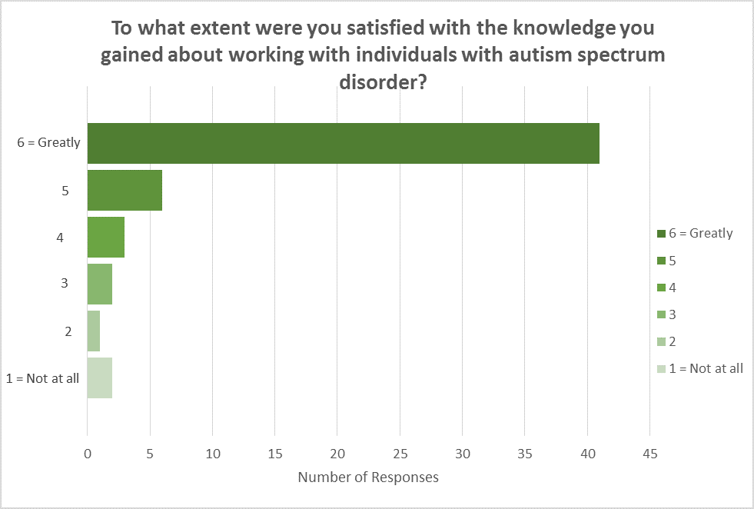
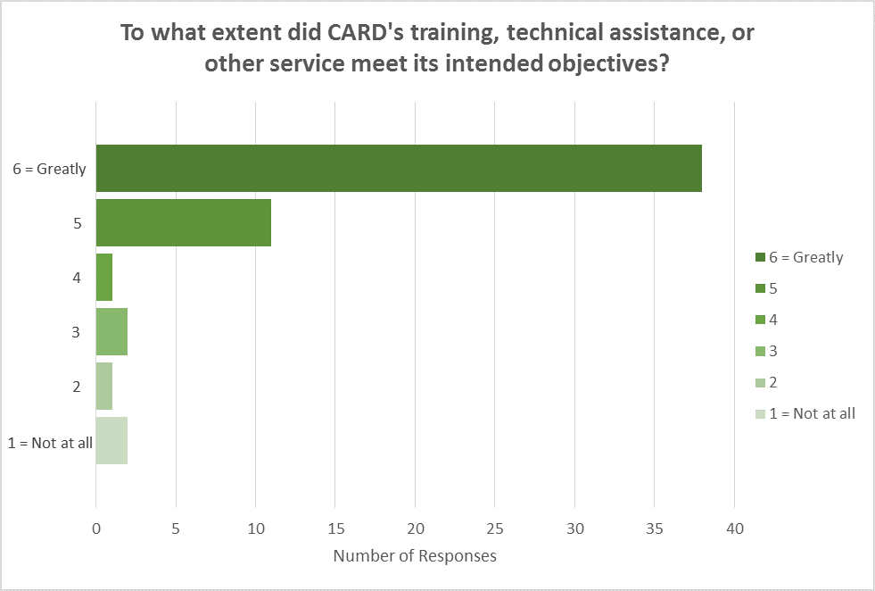
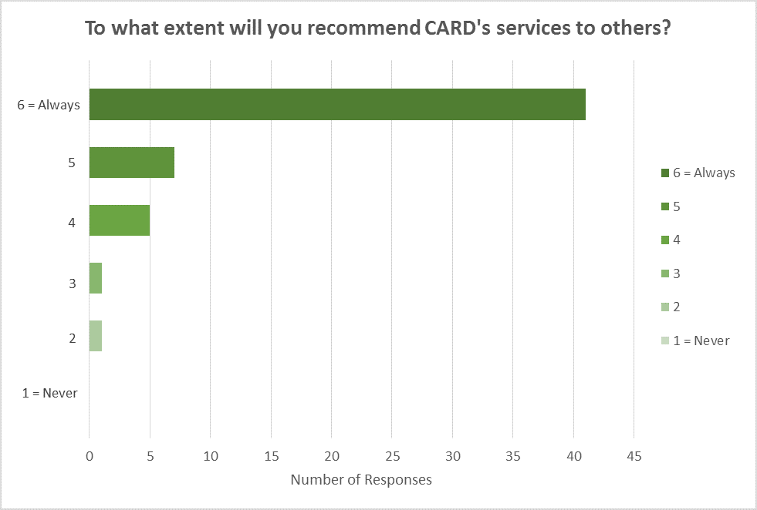
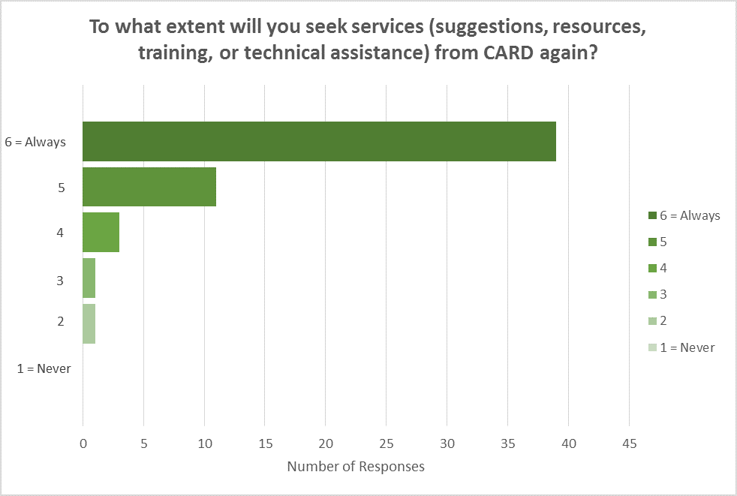
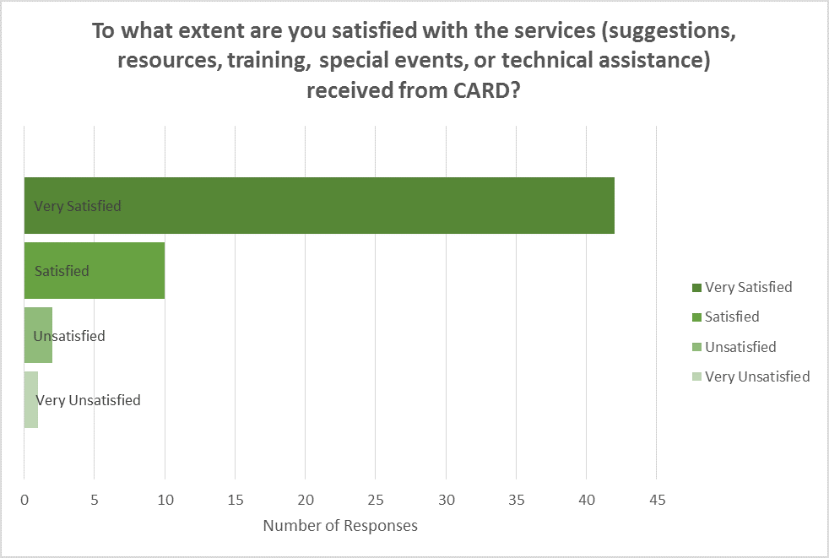
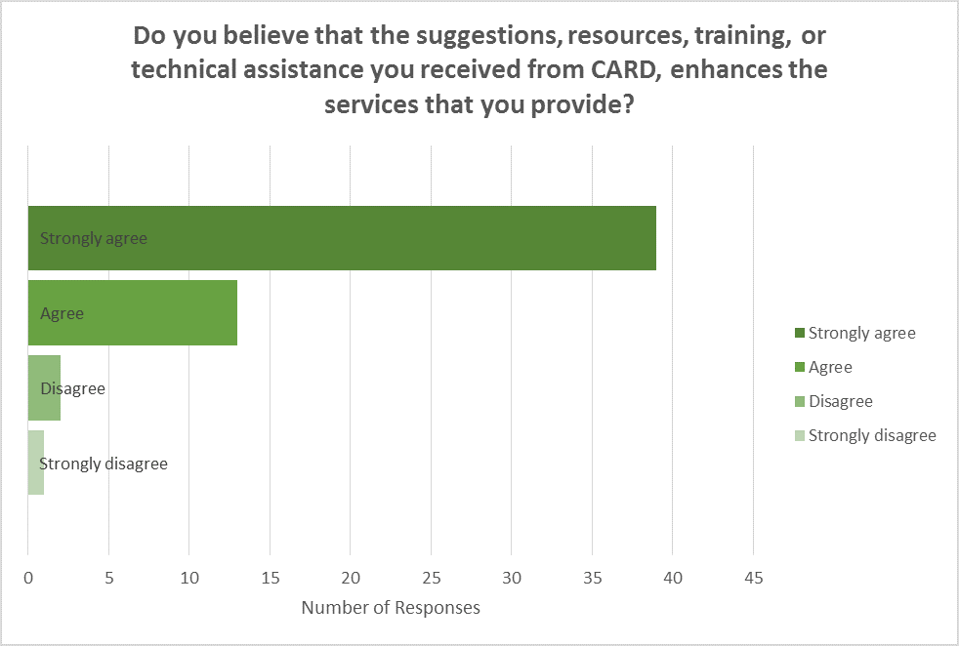
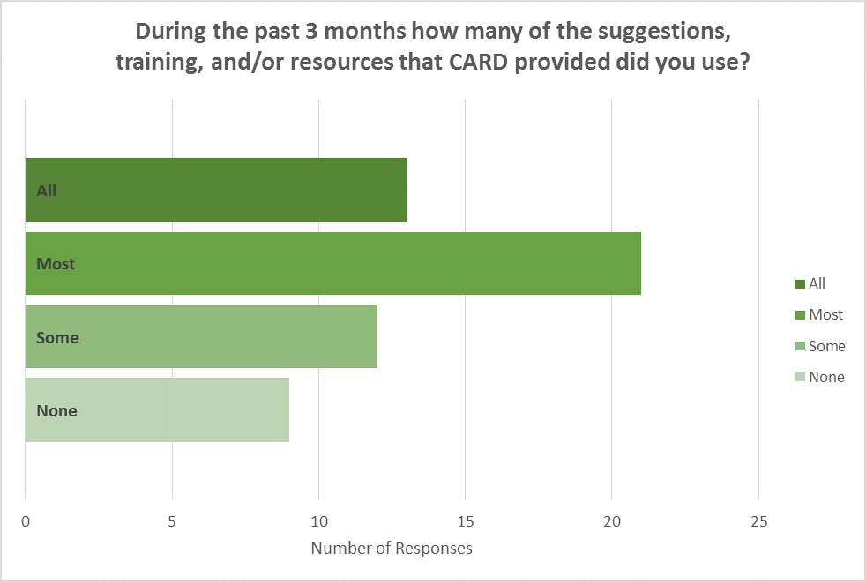
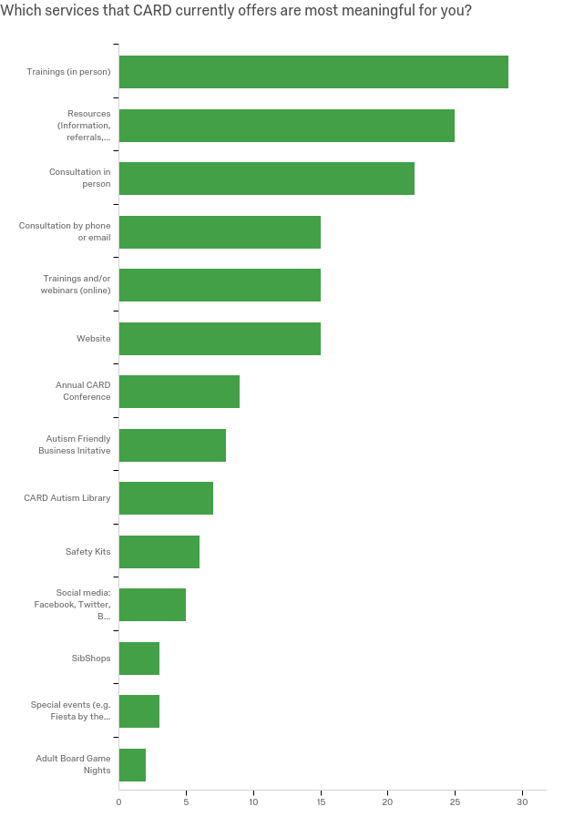
Constituency Board Objectives

1) Continue to meet on at least a quarterly basis.

2) Submit a final report of annual board activities to USF president, Dr. Judy Genshaft.

3) Review activities and outcomes of specific support efforts undertaken by CARD.

- Coordinate planning and implementation of annual fundraising events such as Fiesta By the Bay as well as participation in other regional events.

- Support workgroup activities in the areas of fundraising, community outreach and education.

I have reviewed this document and on behalf of the constituency board of CARD-USF, approve the final report for the year 2017-2018.

_______________________________________ __________________

Kristen Nieves, Board Chair Date
CARD-USF

